* After creating the instance go to volume option in elastic block store 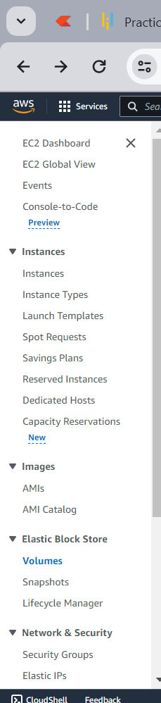
* Click on the create volume button on right hand side of the window 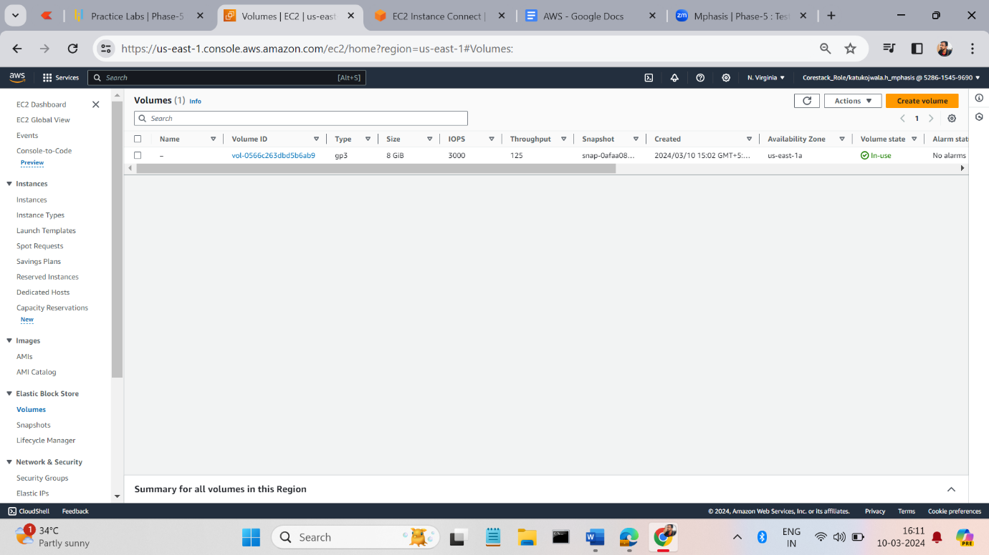
* Enter the required details dependents on your project 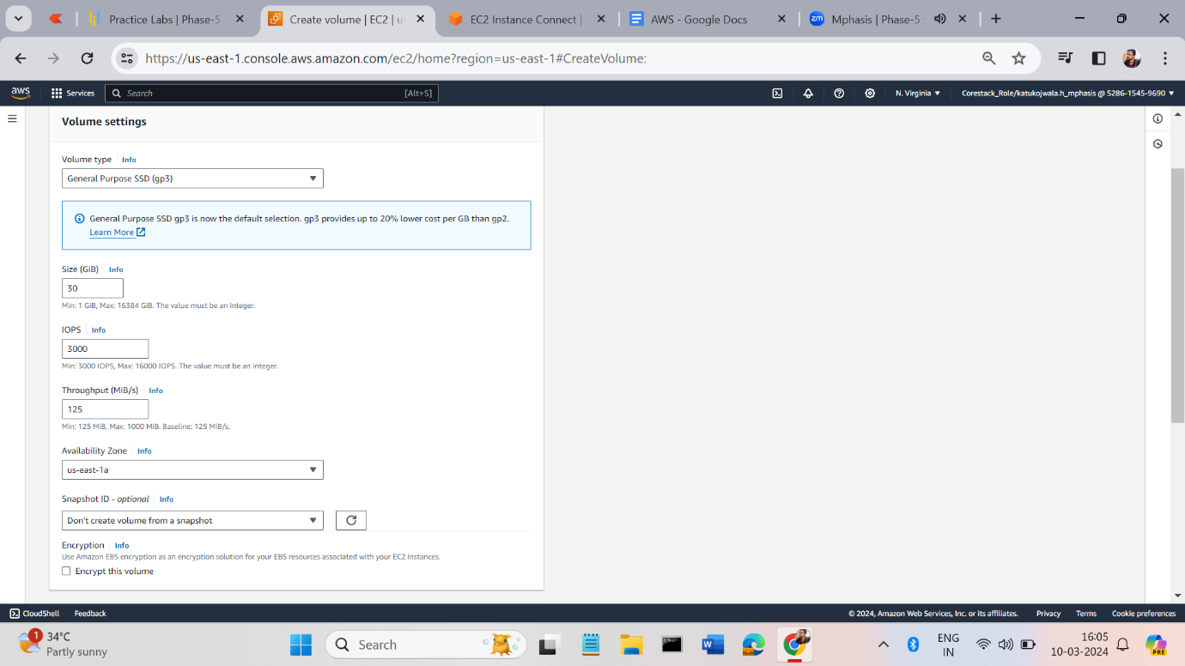
* Press create button volume will be added to your volume list 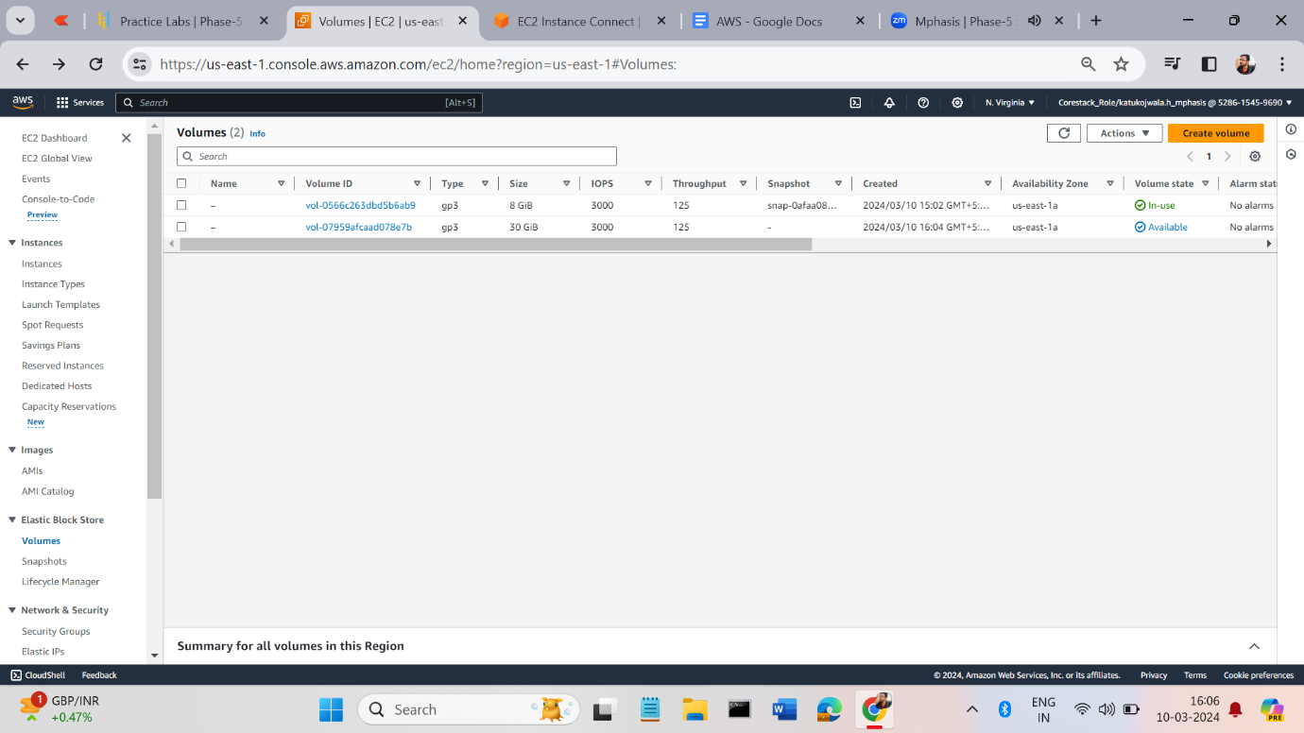
* After creating the volume attaché to the instance. By clicking on action dropdown list and click on the attach volume option. 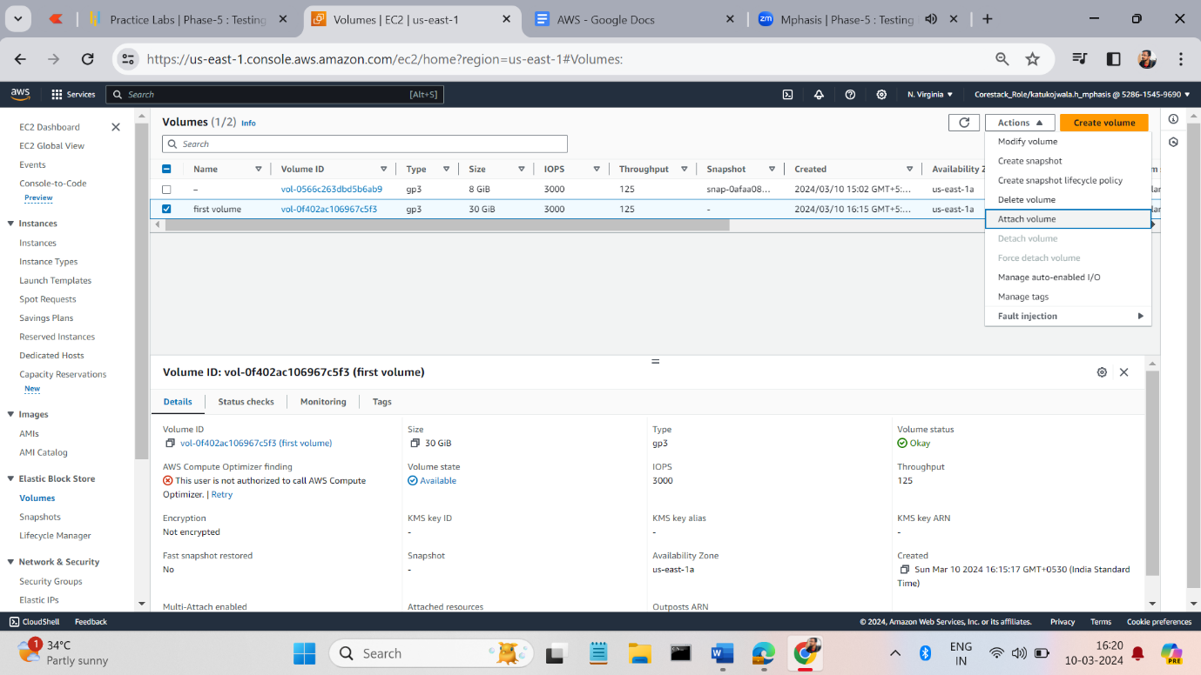
* It will show the instance details to which volume to attach. Give the following details and click on the attach button as show the below image. 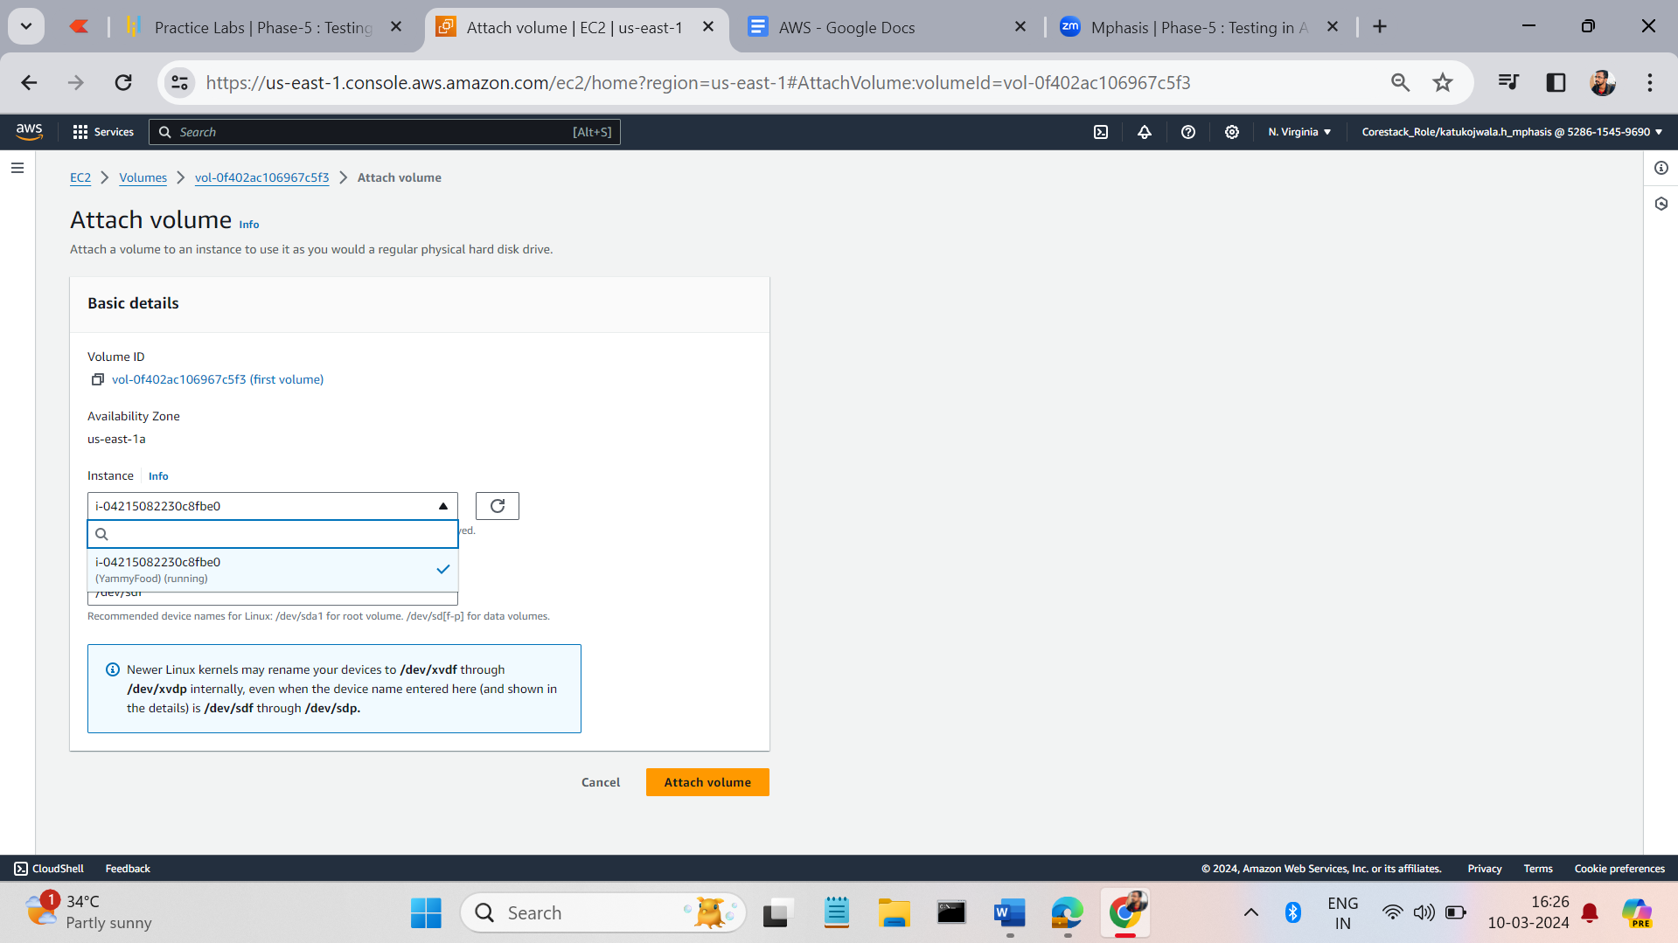
* To modify the volume, click on the volume, it will show the volume details, On the right-hand side you can see the button lick action, delete, and modify buttons click on the modify button and enter the modify details click on the modify button. 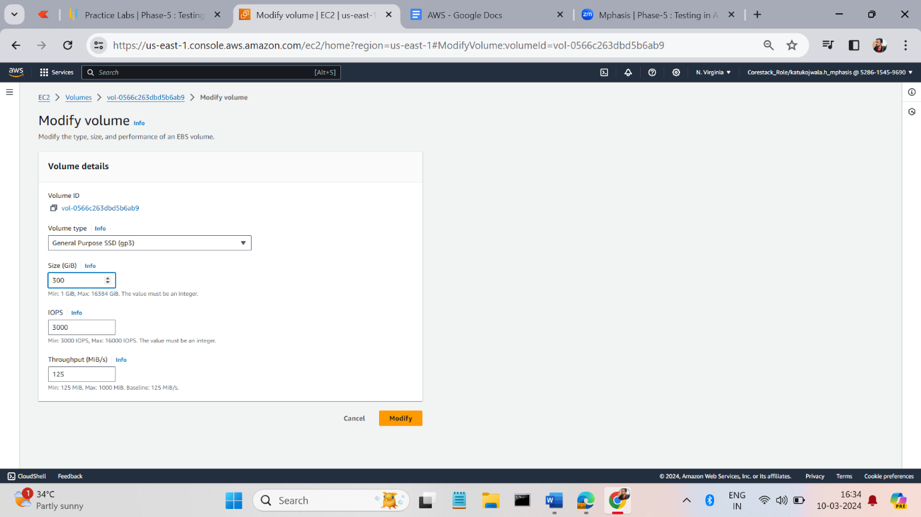
* You can see the modify details by clicking on the volume.

